**TIME SERIES ANALYSIS OF ANNUAL AND SEASONAL RAINFALL IN THE MALABAR REGION DURING THE PERIOD 2012-21**

PROJECT WORK

Project submitted to the University of Calicut in Partial Fulfilment of the Requirement Award of the degree of

**BACHELOR OF SCIENCE IN STATISTICS**



**UNIVERSITY OF CALICUT**

UNDER THE SUPERVISION AND GUIDANCE OF

**Dr. GIRISH BABU M**

**(**HOD OF STATISTICS**)**



**CHMKM GOVT. ARTS AND SCIENCE COLLEGE KODUVALLY**

**(AFFILIATED TO THE UNIVERSITY OF CALICUT)**

**2020-2023**

**DEPARTMENT OF STATISTICS**

**CHMKM GOVT ARTS AND SCIENCE COLLEGE KODUVALLY**

**CERTIFICATE**

This is to certify that ………………………………………………………………………………………..is a bonafide student of the Department of Statistics ,**CHMKM GOVT. ARTS AND SCIENCE COLLEGE KODUVALLY** ,and this project reportentitled **“TIME SERIES ANALYSIS OF ANNUAL AND SESONAL RAINFALL IN THE MALABAR REGION DURING THE PERIOD 2012-21”** has been prepared by in partial fulfilment of the requirement for the award of degree of **BACHELOR OF SCIENCE IN STATISTICS**, under the **University of Calicut** .

**Place: HOD OF STATISTICS**

**Date: Dr. GIRISH BABU M**

Valued by,

**EXTERNAL EXAMINER : ……………………………**

**DECLARATION**

I…………………………………………………………………………………do here by declare that, this project entitled **“TIME SERIES ANALYSIS OF ANNUAL AND SESONAL RAINFALL ANALYSIS IN THE MALABAR REGION DURING THE PERIOD 2012-21”** is the original work done by the guidance of **Dr. GIRISH BABU M**, DEPARTMENT OF STATISTICS, CHMKM GOVT ARTS AND SCIENCE COLLEGE KODUVALLY.

I also declare that this project has not been submitted previously fully or partially by me for the aware of any degree, diploma title or recognition.

Place: Date:

Name: Signature:

Project submitted in partial fulfilment of requirement to award the Degree of **Bsc. Statistics**,

**Prepared by ,**

PRAJUSHA M J (KXAUSST015)

SHYNI K (KXAUSST016)

SNEHA K (KXAUSST017)

NOUFAL K M (KXAUSST023)

SARATH P M (KXAUSST024)

**Guided by,**

**Dr. GIRISH BABU M**

**Ms. AIFOONA AHAMMED P M**

**ACKNOWLEDGEMENT**

At the completion of our project, We express our sincere gratitude to all have supported and provided with the necessary guidance to do so. We would use it as wonderful opportunity to thank Almighty God, Science and Technology for all kind of blessings to bring out of this project work successfully.

We use the opportunity to thank **Dr. SAJEEV P V** the Principal of CHMKM Govt. Arts and Science College, who supported us throughout this project.

We would like to express our deep gratitude towards **Dr. GIRISH BABU M**, HOD of statistics, for his valuable suggestion during the planning and development of this work.

We most sincerely express our gratitude to **Ms. AIFOONA AHAMMED P M**, our project guide for helping us in all possible ways and providing us support and cooperation towards the fulfilment of the project.

We have to express our appreciation to the **Department of Statistics**, sharing their appeals of wisdom with us during the course of this project.

We express our sincere thanks to our **Department Faculties** for guiding us efficiently throughout this project.

**CONTENTS**

|  |  |  |
| --- | --- | --- |
| **SI NO.** | **CHAPTER** | **PAGE NO.** |
| 1 | INTRODUCTION | 7-8 |
|  | OBJECTIVES | 9 |
| 2 | METHODOLOGY | 10-12 |
| 3 | ANALYSIS AND RESULTS | 13-43 |
| 4 | CONCLUSION | 44-45 |
| 5 | BIBILIOGRAPHY | 46 |
| 6 | APPENDIX | 47-49 |

**CHAPTER 1**

**INTRODUCTION**

Several researchers studied on variability and trends in rainfall across the world. Attempts have been made to study trends in annul and seasonal rainfall over India since the beginning of the last century. Annual and southwest monsoon rainfall showed significant decreasing trend over Kerala. studies reveal that there is no similarity in rainfall trends at the regional level.

Kerala State is located between 8°15'N and 12-50'Nlatitudes and between 74°50'E and 77°30'E longitudes.The State of Kerala is popularly known as the ‘‘Gateway of summer monsoon’’ over India. It is a strip of land running almost in North–South direction and is situated between the West Arabian sea on the West and the ranges of Western Ghats and Nilgiri hills on the East both running parallel to each other. From the Western Ghats, the State undulates to the West and presents a series of hills and valleys intersected by numerous rivers. On extreme West, the State is more or less flat. These characteristics demarcate the State into three natural regions viz., the eastern high lands, the hilly midlands and western low lands. The changes in the geographical and topographical features due to man-made interventions are likely to influence atmospheric circulation altitudinally to a large extent. It may be one of the reasons in recent times for uncertainties in monsoon variability and rainfall distribution over Kerala. The long-term variation of monthly, annual and seasonal rainfall over Kerala which is known as the ‘‘Gateway of summer monsoon’’ over India. The average annual rainfall in the Malabar region is very high which is more than 250 cm, it receives rainfall from the Arabian sea branch of the monsoon. The Malabar region is wedged between the Western ghats and the Arabian sea, Malabar covers the geographical area, north of the Bharathapuzha, stretching over parts of Palakkad, Malappuram, Kozhikode, Wayanad, Kannur and Kasaragod districts of Kerala. The western ghats in this region cause topographical rainfall here. The annual range of temperature is 3°C along the Malabar coast and quite 25°C within the interiors. This is because the Malabar coast is a neighbourhood within the south western India which comprises of the many wetlands thanks to which they receive heavy rainfall as they're surrounded by Arabian Sea.

Time Series is a series of data by graphs, list or other forms. It can predict ahead data trend of the series. A Time Series is a series of data points ordered in times. Time Series adds and explicit order dependence between observations: a time dimension. In a normal machine learning data set, the dataset is a collection of observations that are treated equally when future is being predicted. In Time Series the order of observations provides a source of additional information that should be analysed and used in prediction process. Most commonly, a time series is sequence at successive equally spaced points in time.Thus it is a sequence of discrete-time data. Time series forecasting is the use of the model to predict future values based on previously observed values.

A trend is the slow variation over a longer period of time, usually several years, generally associated with the structural causes affecting the phenomenon being measured. A trend is a pattern found in time series datasets; it is used to describe if the data is showing an upward or downward movement for part, or all of, the time series.

We are analysing Annual and four seasons of rainfall that are Winter, Pre monsoon, Monsoon and Post Monsoon over Malabar region in Kerala. We are collected the data from the Meteorological department of Indian Government.

**CHAPTER 1.1**

**OBJECTIVES**

* The main objective of our project is, Time series analysis of the rainfall over Malabar Region of Kerala state during the time period 2012-2021.
* Time Series Modelling of Annual and Seasonal Rainfall over Malabar Region during the time period 2012-2021 using exponential smoothing and ARIMA model.
* To find the Seasonal Trend of the rainfall during the seasons

Winter, Pre monsoon, Monsoon and Post Monsoon.

**CHAPTER 2**

**METHODOLOGY**

* STATISTICAL TOOLS USED:

1. Time Series Analysis:

Time series analysis is a specific way of analysing a sequence of data points collected over an interval of time. In time series analysis, analysts record data points at consistent intervals over a set period of time rather than just recording the data points intermittently or randomly. However, this type of analysis is not merely the act of collecting data over time. What sets time series data apart from other data is that the analysis can show how variables change over time. In other words, time is a crucial variable because it shows how the data adjusts over the course of the data points as well as the final results. It provides an additional source of information and a set order of dependencies between the data.

Time series analysis typically requires a large number of data points to ensure consistency and reliability. An extensive data set ensures you have a representative sample size and that analysis can cut through noisy data. It also ensures that any trends or patterns discovered are not outliers and can account for seasonal variance. Additionally, time series data can be used for forecasting—predicting future data based on historical data.

1. Exponential Smoothing:

Exponential smoothing was first suggested in the statistical literature without reference to previous work by Robert Goodell Brown in 1956 and then- expanded by Charles C. Holt in 1957. Exponential smoothing is a broadly accurate principle for smoothing time series data using the exponential window function. The controlling input of the exponential smoothing calculation is defined as the smoothing factor or the smoothing constant.

As we know that, in the simple moving average, the past observations are weighted equally, exponential functions are used to assign exponentially decreasing weights over time. It is an easily learned and easily applied method for making some determination based on prior assumptions by the user, such as seasonality. Exponential smoothing is generally used for the analysis of time-series data.

1. ARIMA MODEL:

In Statistics, particularly in time series analysis, an **autoregressive integrated moving average** (**ARIMA**) model is a generalization of an [autoregressive moving average](https://en.wikipedia.org/wiki/Autoregressive_moving_average) (ARMA) model. To better comprehend the data or to forecast upcoming series points, both of these models are fitted to [time series](https://en.wikipedia.org/wiki/Time_series) data. ARIMA models are applied in some cases where data show evidence of [non-stationarity](https://en.wikipedia.org/wiki/Stationary_process) in the sense of mean (but not variance/[autocovariance](https://en.wikipedia.org/wiki/Autocovariance)), where an initial differencing step (corresponding to the ["integrated"](https://en.wikipedia.org/wiki/Order_of_integration) part of the model) can be applied one or more times to eliminate the non-stationarity of the mean function (i.e., the trend). When the seasonality shows in a time series, the seasonal-differencingcould be applied to eliminate the seasonal component.

1. SEASONAL DECOMPOSITION:

The decomposition of time series is a statistical task that deconstructs a time series into several components, each representing one of the underlying categories of patterns. There are two principal types of decomposition.

Decomposition provides a useful abstract model for thinking about time series generally and for better understanding problems during time series analysis and forecasting.

* SOFTWARES USED:

1. MS EXCEL:

Excel uses a large collection of cells formatted to organize and manipulate data and solve mathematical functions. Users can arrange data in the spreadsheet using graphing tools, pivot tables and formulas. The spreadsheet application also has a macro programming language called Visual Basic for Applications.

1. MS WORD:

Microsoft word is a word processor software developed by Microsoft in 1983. It is the most commonly used word processor software. It is used to create professional quality documents, letters, reports, resumes, etc and also allows you to edit or modify your new or existing document. The file saved in Ms Word has .docx extension. It is a component of the Microsoft Office suite.

1. IBM SPSS STATISTICS 25:

IBM SPSS Statistics is a powerful statistical software platform. It offers a user-friendly interface and a robust set of features that lets your organization quickly extract actionable insights from your data. Advanced statistical procedures help ensure high accuracy and quality decision making. All facets of the analytics lifecycle are included, from data preparation and management to analysis and reporting.

* Secondary Data that is Rainfall data (in mm) required for the analysis is published by the Indian Meteorological Department.

CHAPTER 3

**ANALYSIS**

And

**RESULTS**

KASARAGOD

SEASONAL RAINFALL ANALYSIS

|  |  |
| --- | --- |
| **Seasonal Factors** | |
| Series Name: RAINFALL | |
| Period | Seasonal Factor (%) |
| 1 | 2.0 |
| 2 | 28.5 |
| 3 | 335.4 |
| 4 | 34.1 |

**Model Summary**

|  |  |  |  |  |  |  |  |  |  |  |  |
| --- | --- | --- | --- | --- | --- | --- | --- | --- | --- | --- | --- |
| **Model Fit** | | | | | | | | | | | |
| Fit Statistic | Mean | | SE | | Minimum | | Maximum | Percentile | | | |
| 5 | | 10 | |
| Stationary R-squared | .737 | | . | | .737 | | .737 | .737 | | .737 | |
| R-squared | .942 | | . | | .942 | | .942 | .942 | | .942 | |
| RMSE | 280.646 | | . | | 280.646 | | 280.646 | 280.646 | | 280.646 | |
| MAPE | 131.763 | | . | | 131.763 | | 131.763 | 131.763 | | 131.763 | |
| MaxAPE | 1751.076 | | . | | 1751.076 | | 1751.076 | 1751.076 | | 1751.076 | |
| MAE | 176.350 | | . | | 176.350 | | 176.350 | 176.350 | | 176.350 | |
| MaxAE | 879.961 | | . | | 879.961 | | 879.961 | 879.961 | | 879.961 | |
| Normalized BIC | 11.459 | | . | | 11.459 | | 11.459 | 11.459 | | 11.459 | |
|  | | | | | | | | | | | | |
|  | | | | | | | | | | | | |
| Fit Statistic | | Percentile | | | | | | | | | | |
| 25 | | 50 | | 75 | | | 90 | | 95 | |
| Stationary R-squared | | .737 | | .737 | | .737 | | | .737 | | .737 | |
| R-squared | | .942 | | .942 | | .942 | | | .942 | | .942 | |
| RMSE | | 280.646 | | 280.646 | | 280.646 | | | 280.646 | | 280.646 | |
| MAPE | | 131.763 | | 131.763 | | 131.763 | | | 131.763 | | 131.763 | |
| MaxAPE | | 1751.076 | | 1751.076 | | 1751.076 | | | 1751.076 | | 1751.076 | |
| MAE | | 176.350 | | 176.350 | | 176.350 | | | 176.350 | | 176.350 | |
| MaxAE | | 879.961 | | 879.961 | | 879.961 | | | 879.961 | | 879.961 | |
| Normalized BIC | | 11.459 | | 11.459 | | 11.459 | | | 11.459 | | 11.459 | |

|  |  |  |  |  |  |
| --- | --- | --- | --- | --- | --- |
| **Model Statistics** | | | | | |
| Model | Number of Predictors | Model Fit statistics | | Ljung-Box Q(18) | |
| Stationary R-squared | R-squared | Statistics | DF |
| RAINFALL-Model_1 | 0 | .737 | .942 | 20.930 | 16 |

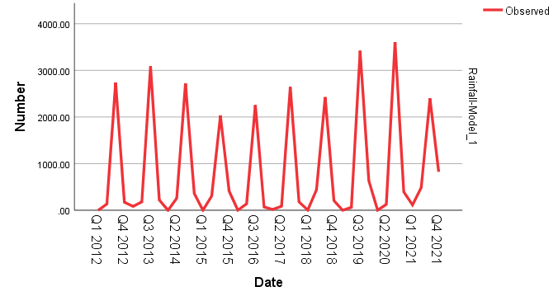

ANNUAL RAINFALL ANALYSIS

**Model Summary**

|  |  |  |  |  |  |  |
| --- | --- | --- | --- | --- | --- | --- |
| **Model Fit** | | | | | | |
| Fit Statistic | Mean | SE | Minimum | Maximum | Percentile | |
| 5 | 10 |
| Stationary R-squared | -.032 | . | -.032 | -.032 | -.032 | -.032 |
| R-squared | .265 | . | .265 | .265 | .265 | .265 |
| RMSE | 490.545 | . | 490.545 | 490.545 | 490.545 | 490.545 |
| MAPE | 10.867 | . | 10.867 | 10.867 | 10.867 | 10.867 |
| MaxAPE | 25.191 | . | 25.191 | 25.191 | 25.191 | 25.191 |
| MAE | 359.381 | . | 359.381 | 359.381 | 359.381 | 359.381 |
| MaxAE | 1036.600 | . | 1036.600 | 1036.600 | 1036.600 | 1036.600 |
| Normalized BIC | 12.621 | . | 12.621 | 12.621 | 12.621 | 12.621 |

|  |  |  |  |  |  |
| --- | --- | --- | --- | --- | --- |
| **Model Fit** | | | | | |
| Fit Statistic | Percentile | | | | |
| 25 | 50 | 75 | 90 | 95 |
| Stationary R-squared | -.032 | -.032 | -.032 | -.032 | -.032 |
| R-squared | .265 | .265 | .265 | .265 | .265 |
| RMSE | 490.545 | 490.545 | 490.545 | 490.545 | 490.545 |
| MAPE | 10.867 | 10.867 | 10.867 | 10.867 | 10.867 |
| MaxAPE | 25.191 | 25.191 | 25.191 | 25.191 | 25.191 |
| MAE | 359.381 | 359.381 | 359.381 | 359.381 | 359.381 |
| MaxAE | 1036.600 | 1036.600 | 1036.600 | 1036.600 | 1036.600 |
| Normalized BIC | 12.621 | 12.621 | 12.621 | 12.621 | 12.621 |

|  |  |  |  |  |  |
| --- | --- | --- | --- | --- | --- |
| **Model Statistics** | | | | | |
| Model | Number of Predictors | Model Fit statistics | | Ljung-Box Q(18) | |
| Stationary R-squared | R-squared | Statistics | DF |
| RAINFALL-Model_1 | 0 | -.032 | .265 | . | 0 |

|  |  |  |  |  |  |
| --- | --- | --- | --- | --- | --- |
| **Exponential Smoothing Model Parameters** | | | | | |
| Model | | | Estimate | SE | t |
| RAINFALL-Model_1 | No Transformation | Alpha (Level) | 1.000 | .320 | 3.125 |

|  |  |  |  |
| --- | --- | --- | --- |
| **Exponential Smoothing Model Parameters** | | | |
| Model | | | Sig. |
| RAINFALL-Model_1 | No Transformation | Alpha (Level) | .012 |

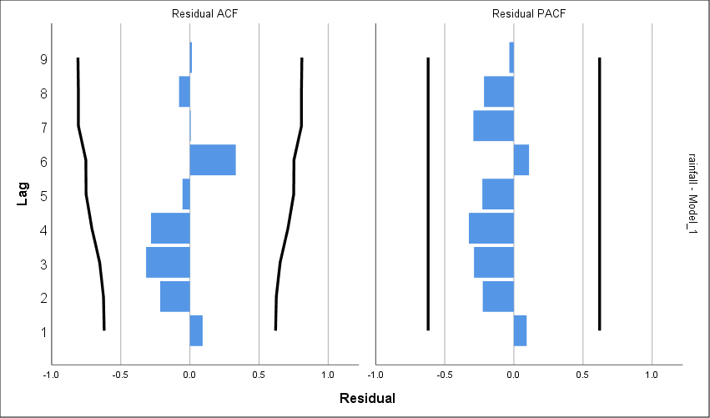

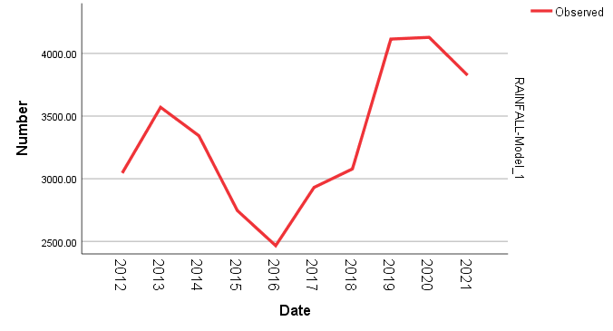

INFERENCE:

1) Annual rainfall analysis shows an increasing trend.

2) 2019 and 2020 have the highest rainfall during the period 2012-2021.

3) 2016 has the least rainfall during the period 2012-2021.

KANNUR

SEASONAL RAINFALL ANALYSIS

|  |  |
| --- | --- |
| **Seasonal Factors** | |
| Series Name: rainfall | |
| Period | Seasonal Factor (%) |
| 1 | 1.3 |
| 2 | 31.1 |
| 3 | 325.6 |
| 4 | 42.0 |

|  |  |  |  |  |  |  |
| --- | --- | --- | --- | --- | --- | --- |
| **Model Fit** | | | | | | |
| Fit Statistic | Mean | SE | Minimum | Maximum | Percentile | |
| 5 | 10 |
| Stationary R-squared | .736 | . | .736 | .736 | .736 | .736 |
| R-squared | .929 | . | .929 | .929 | .929 | .929 |
| RMSE | 298.474 | . | 298.474 | 298.474 | 298.474 | 298.474 |
| MAPE | 269.518 | . | 269.518 | 269.518 | 269.518 | 269.518 |
| MaxAPE | 4242.314 | . | 4242.314 | 4242.314 | 4242.314 | 4242.314 |
| MAE | 199.771 | . | 199.771 | 199.771 | 199.771 | 199.771 |
| MaxAE | 782.235 | . | 782.235 | 782.235 | 782.235 | 782.235 |
| Normalized BIC | 11.582 | . | 11.582 | 11.582 | 11.582 | 11.582 |

|  |  |  |  |  |  |
| --- | --- | --- | --- | --- | --- |
| **Model Fit** | | | | | |
| Fit Statistic | Percentile | | | | |
| 25 | 50 | 75 | 90 | 95 |
| Stationary R-squared | .736 | .736 | .736 | .736 | .736 |
| R-squared | .929 | .929 | .929 | .929 | .929 |
| RMSE | 298.474 | 298.474 | 298.474 | 298.474 | 298.474 |
| MAPE | 269.518 | 269.518 | 269.518 | 269.518 | 269.518 |
| MaxAPE | 4242.314 | 4242.314 | 4242.314 | 4242.314 | 4242.314 |
| MAE | 199.771 | 199.771 | 199.771 | 199.771 | 199.771 |
| MaxAE | 782.235 | 782.235 | 782.235 | 782.235 | 782.235 |
| Normalized BIC | 11.582 | 11.582 | 11.582 | 11.582 | 11.582 |

|  |  |  |  |  |  |
| --- | --- | --- | --- | --- | --- |
| **Model Statistics** | | | | | |
| Model | Number of Predictors | Model Fit statistics | Ljung-Box Q(18) | | |
| Stationary R-squared | Statistics | DF | Sig. |
| rainfall-Model_1 | 0 | .736 | 17.658 | 16 | .344 |

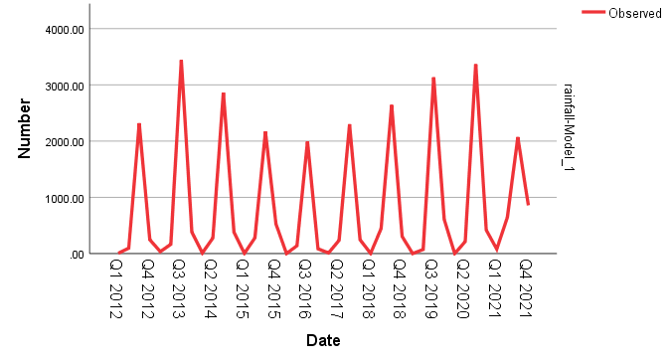

ANNUAL RAINFALL ANALYSIS

**Model Summary**

|  |  |  |  |  |  |  |
| --- | --- | --- | --- | --- | --- | --- |
| **Model Fit** | | | | | | |
| Fit Statistic | Mean | SE | Minimum | Maximum | Percentile | |
| 5 | 10 |
| Stationary R-squared | 5.995E-15 | . | 5.995E-15 | 5.995E-15 | 5.995E-15 | 5.995E-15 |
| R-squared | 5.995E-15 | . | 5.995E-15 | 5.995E-15 | 5.995E-15 | 5.995E-15 |
| RMSE | 580.132 | . | 580.132 | 580.132 | 580.132 | 580.132 |
| MAPE | 16.386 | . | 16.386 | 16.386 | 16.386 | 16.386 |
| MaxAPE | 43.872 | . | 43.872 | 43.872 | 43.872 | 43.872 |
| MAE | 495.450 | . | 495.450 | 495.450 | 495.450 | 495.450 |
| MaxAE | 972.030 | . | 972.030 | 972.030 | 972.030 | 972.030 |
| Normalized BIC | 12.957 | . | 12.957 | 12.957 | 12.957 | 12.957 |

|  |  |  |  |  |  |
| --- | --- | --- | --- | --- | --- |
| **Model Fit** | | | | | |
| Fit Statistic | Percentile | | | | |
| 25 | 50 | 75 | 90 | 95 |
| Stationary R-squared | 5.995E-15 | 5.995E-15 | 5.995E-15 | 5.995E-15 | 5.995E-15 |
| R-squared | 5.995E-15 | 5.995E-15 | 5.995E-15 | 5.995E-15 | 5.995E-15 |
| RMSE | 580.132 | 580.132 | 580.132 | 580.132 | 580.132 |
| MAPE | 16.386 | 16.386 | 16.386 | 16.386 | 16.386 |
| MaxAPE | 43.872 | 43.872 | 43.872 | 43.872 | 43.872 |
| MAE | 495.450 | 495.450 | 495.450 | 495.450 | 495.450 |
| MaxAE | 972.030 | 972.030 | 972.030 | 972.030 | 972.030 |
| Normalized BIC | 12.957 | 12.957 | 12.957 | 12.957 | 12.957 |

|  |  |  |  |  |  |
| --- | --- | --- | --- | --- | --- |
| **Model Statistics** | | | | | |
| Model | Number of Predictors | Model Fit statistics | | Ljung-Box Q(18) | |
| Stationary R-squared | R-squared | Statistics | DF |
| RAINFALL-Model_1 | 0 | 5.995E-15 | 5.995E-15 | . | 0 |

|  |  |  |  |  |  |
| --- | --- | --- | --- | --- | --- |
| **ARIMA Model Parameters** | | | | | |
|  | | | | Estimate | SE |
| RAINFALL-Model_1 | RAINFALL | No Transformation | Constant | 3187.630 | 183.454 |

|  |  |  |  |  |  |
| --- | --- | --- | --- | --- | --- |
| **ARIMA Model Parameters** | | | | | |
|  | | | | t | Sig. |
| RAINFALL-Model_1 | RAINFALL | No Transformation | Constant | 17.376 | .000 |

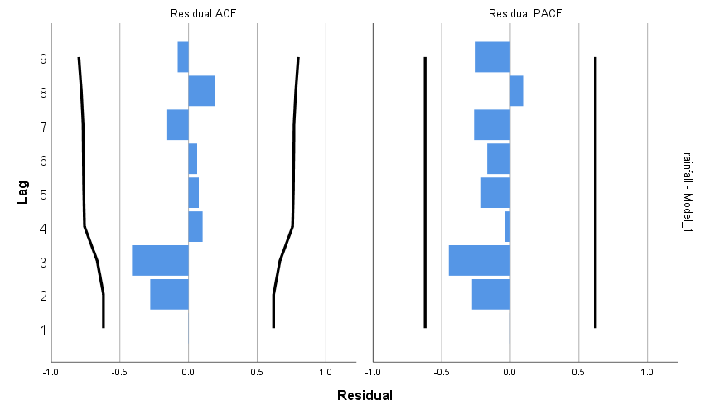

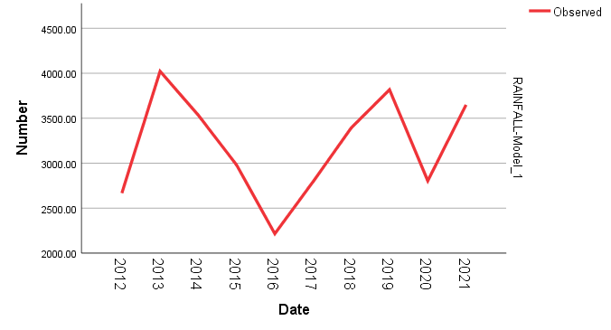

INFERENCE:

1) Annual rainfall analysis shows an increasing trend.

2) 2013 has the highest rainfall during the period 2012-2021.

3) 2016 has the least rainfall during the period 2012-2021.

WAYANAD

SEASONAL RAINFALL ANALYSIS

|  |  |
| --- | --- |
| **Seasonal Factors** | |
| Series Name: RAINFALL | |
| Period | Seasonal Factor (%) |
| .1 | 1.6 |
| 2 | 47.8 |
| 3 | 310.3 |
| 4 | 40.2 |

**Model Summary**

|  |  |  |  |  |  |  |
| --- | --- | --- | --- | --- | --- | --- |
| **Model Fit** | | | | | | |
| Fit Statistic | Mean | SE | Minimum | Maximum | Percentile | |
| 5 | 10 |
| Stationary R-squared | .671 | . | .671 | .671 | .671 | .671 |
| R-squared | .855 | . | .855 | .855 | .855 | .855 |
| RMSE | 333.611 | . | 333.611 | 333.611 | 333.611 | 333.611 |
| MAPE | 1699.677 | . | 1699.677 | 1699.677 | 1699.677 | 1699.677 |
| MaxAPE | 60183.228 | . | 60183.228 | 60183.228 | 60183.228 | 60183.228 |
| MAE | 191.212 | . | 191.212 | 191.212 | 191.212 | 191.212 |
| MaxAE | 1139.753 | . | 1139.753 | 1139.753 | 1139.753 | 1139.753 |
| Normalized BIC | 11.804 | . | 11.804 | 11.804 | 11.804 | 11.804 |

|  |  |  |  |  |  |
| --- | --- | --- | --- | --- | --- |
| **Model Fit** | | | | | |
| Fit Statistic | Percentile | | | | |
| 25 | 50 | 75 | 90 | 95 |
| Stationary R-squared | .671 | .671 | .671 | .671 | .671 |
| R-squared | .855 | .855 | .855 | .855 | .855 |
| RMSE | 333.611 | 333.611 | 333.611 | 333.611 | 333.611 |
| MAPE | 1699.677 | 1699.677 | 1699.677 | 1699.677 | 1699.677 |
| MaxAPE | 60183.228 | 60183.228 | 60183.228 | 60183.228 | 60183.228 |
| MAE | 191.212 | 191.212 | 191.212 | 191.212 | 191.212 |
| MaxAE | 1139.753 | 1139.753 | 1139.753 | 1139.753 | 1139.753 |
| Normalized BIC | 11.804 | 11.804 | 11.804 | 11.804 | 11.804 |

|  |  |  |  |  |  |  |  |  |  |  |
| --- | --- | --- | --- | --- | --- | --- | --- | --- | --- | --- |
| **Model Statistics** | | | | | | | | | | |
| Model | Number of Predictors | | Model Fit statistics | | Ljung-Box Q(18) | | | | | |
| Stationary R-squared | | Statistics | | DF | | Sig. | |
| RAINFALL-Model_1 | | 0 | | .671 | | 35.108 | | 16 | | .004 | |

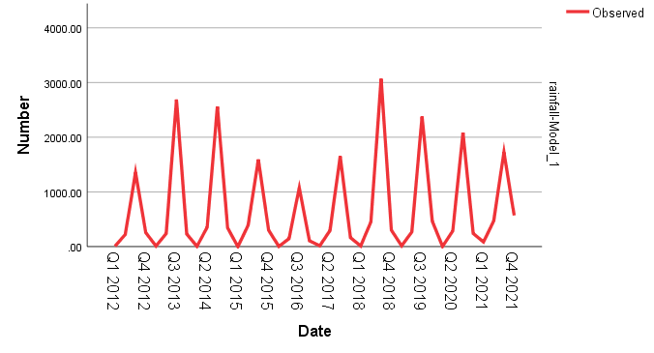

ANNUAL RAINFALL ANALYSIS

**Model Summary**

|  |  |  |  |  |  |  |
| --- | --- | --- | --- | --- | --- | --- |
| **Model Fit** | | | | | | |
| Fit Statistic | Mean | SE | Minimum | Maximum | Percentile | |
| 5 | 10 |
| Stationary R-squared | 1.665E-15 | . | 1.665E-15 | 1.665E-15 | 1.665E-15 | 1.665E-15 |
| R-squared | 1.665E-15 | . | 1.665E-15 | 1.665E-15 | 1.665E-15 | 1.665E-15 |
| RMSE | 754.168 | . | 754.168 | 754.168 | 754.168 | 754.168 |
| MAPE | 27.312 | . | 27.312 | 27.312 | 27.312 | 27.312 |
| MaxAPE | 98.977 | . | 98.977 | 98.977 | 98.977 | 98.977 |
| MAE | 604.660 | . | 604.660 | 604.660 | 604.660 | 604.660 |
| MaxAE | 1314.220 | . | 1314.220 | 1314.220 | 1314.220 | 1314.220 |
| Normalized BIC | 13.481 | . | 13.481 | 13.481 | 13.481 | 13.481 |

|  |  |  |  |  |  |
| --- | --- | --- | --- | --- | --- |
| **Model Fit** | | | | | |
| Fit Statistic | Percentile | | | | |
| 25 | 50 | 75 | 90 | 95 |
| Stationary R-squared | 1.665E-15 | 1.665E-15 | 1.665E-15 | 1.665E-15 | 1.665E-15 |
| R-squared | 1.665E-15 | 1.665E-15 | 1.665E-15 | 1.665E-15 | 1.665E-15 |
| RMSE | 754.168 | 754.168 | 754.168 | 754.168 | 754.168 |
| MAPE | 27.312 | 27.312 | 27.312 | 27.312 | 27.312 |
| MaxAPE | 98.977 | 98.977 | 98.977 | 98.977 | 98.977 |
| MAE | 604.660 | 604.660 | 604.660 | 604.660 | 604.660 |
| MaxAE | 1314.220 | 1314.220 | 1314.220 | 1314.220 | 1314.220 |
| Normalized BIC | 13.481 | 13.481 | 13.481 | 13.481 | 13.481 |

|  |  |  |  |  |  |
| --- | --- | --- | --- | --- | --- |
| **Model Statistics** | | | | | |
| Model | Number of Predictors | Model Fit statistics | | Ljung-Box Q(18) | |
| Stationary R-squared | R-squared | Statistics | DF |
| RAINFALL-Model_1 | 0 | 1.665E-15 | 1.665E-15 | . | 0 |

|  |  |  |  |  |  |
| --- | --- | --- | --- | --- | --- |
| **ARIMA Model Parameters** | | | | | |
|  | | | | Estimate | SE |
| RAINFALL-Model_1 | RAINFALL | No Transformation | Constant | 2642.020 | 238.489 |

|  |  |  |  |  |  |
| --- | --- | --- | --- | --- | --- |
| **ARIMA Model Parameters** | | | | | |
|  | | | | t | Sig. |
| RAINFALL-Model_1 | RAINFALL | No Transformation | Constant | 11.078 | .000 |

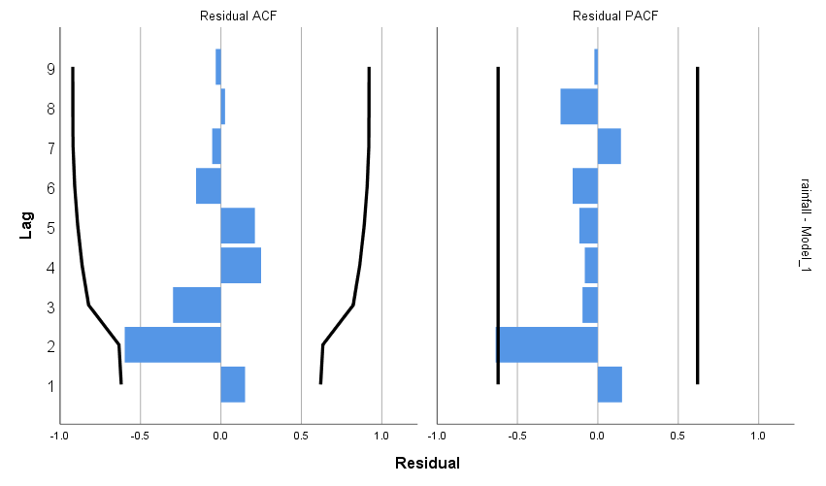

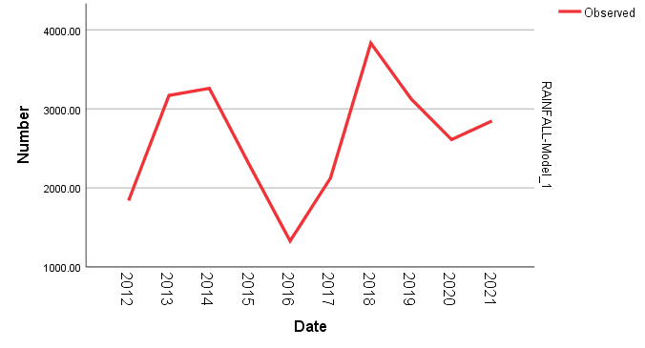

INFERENCE:

1) Annual rainfall analysis shows an increasing trend.

2) 2018 has the highest rainfall during the period 2012-2021.

3) 2016 has the least rainfall during the period 2012-2021.

KOZHIKODE

SEASONAL RAINFALL ANALYSIS

|  |  |
| --- | --- |
| **Seasonal Factors** | |
| Series Name: RAINFALL | |
| Period | Seasonal Factor (%) |
| 1 | 1.1 |
| 2 | 42.6 |
| 3 | 312.2 |
| 4 | 44.1 |

**Model Summary**

|  |  |  |  |  |  |  |
| --- | --- | --- | --- | --- | --- | --- |
| **Model Fit** | | | | | | |
| Fit Statistic | Mean | SE | Minimum | Maximum | Percentile | |
| 5 | 10 |
| Stationary R-squared | .705 | . | .705 | .705 | .705 | .705 |
| R-squared | .927 | . | .927 | .927 | .927 | .927 |
| RMSE | 309.080 | . | 309.080 | 309.080 | 309.080 | 309.080 |
| MAPE | 120.705 | . | 120.705 | 120.705 | 120.705 | 120.705 |
| MaxAPE | 1501.059 | . | 1501.059 | 1501.059 | 1501.059 | 1501.059 |
| MAE | 207.986 | . | 207.986 | 207.986 | 207.986 | 207.986 |
| MaxAE | 777.658 | . | 777.658 | 777.658 | 777.658 | 777.658 |
| Normalized BIC | 11.744 | . | 11.744 | 11.744 | 11.744 | 11.744 |

|  |  |  |  |  |  |
| --- | --- | --- | --- | --- | --- |
| **Model Fit** | | | | | |
| Fit Statistic | Percentile | | | | |
| 25 | 50 | 75 | 90 | 95 |
| Stationary R-squared | .705 | .705 | .705 | .705 | .705 |
| R-squared | .927 | .927 | .927 | .927 | .927 |
| RMSE | 309.080 | 309.080 | 309.080 | 309.080 | 309.080 |
| MAPE | 120.705 | 120.705 | 120.705 | 120.705 | 120.705 |
| MaxAPE | 1501.059 | 1501.059 | 1501.059 | 1501.059 | 1501.059 |
| MAE | 207.986 | 207.986 | 207.986 | 207.986 | 207.986 |
| MaxAE | 777.658 | 777.658 | 777.658 | 777.658 | 777.658 |
| Normalized BIC | 11.744 | 11.744 | 11.744 | 11.744 | 11.744 |

|  |  |  |  |  |  |
| --- | --- | --- | --- | --- | --- |
| **Model Statistics** | | | | | |
| Model | Number of Predictors | Model Fit statistics | | Ljung-Box Q(18) | |
| Stationary R-squared | R-squared | Statistics | DF |
| RAINFALL-Model_1 | 0 | .705 | .927 | 27.053 | 15 |

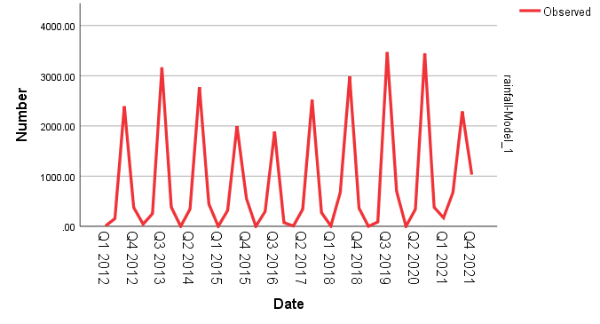

ANNUAL RAINFALL ANALYSIS

**Model Summary**

|  |  |  |  |  |  |  |
| --- | --- | --- | --- | --- | --- | --- |
| **Model Fit** | | | | | | |
| Fit Statistic | Mean | SE | Minimum | Maximum | Percentile | |
| 5 | 10 |
| Stationary R-squared | -.053 | . | -.053 | -.053 | -.053 | -.053 |
| R-squared | .198 | . | .198 | .198 | .198 | .198 |
| RMSE | 614.409 | . | 614.409 | 614.409 | 614.409 | 614.409 |
| MAPE | 14.068 | . | 14.068 | 14.068 | 14.068 | 14.068 |
| MaxAPE | 28.070 | . | 28.070 | 28.070 | 28.070 | 28.070 |
| MAE | 459.630 | . | 459.630 | 459.630 | 459.630 | 459.630 |
| MaxAE | 913.800 | . | 913.800 | 913.800 | 913.800 | 913.800 |
| Normalized BIC | 13.072 | . | 13.072 | 13.072 | 13.072 | 13.072 |

|  |  |  |  |  |  |
| --- | --- | --- | --- | --- | --- |
| **Model Fit** | | | | | |
| Fit Statistic | Percentile | | | | |
| 25 | 50 | 75 | 90 | 95 |
| Stationary R-squared | -.053 | -.053 | -.053 | -.053 | -.053 |
| R-squared | .198 | .198 | .198 | .198 | .198 |
| RMSE | 614.409 | 614.409 | 614.409 | 614.409 | 614.409 |
| MAPE | 14.068 | 14.068 | 14.068 | 14.068 | 14.068 |
| MaxAPE | 28.070 | 28.070 | 28.070 | 28.070 | 28.070 |
| MAE | 459.630 | 459.630 | 459.630 | 459.630 | 459.630 |
| MaxAE | 913.800 | 913.800 | 913.800 | 913.800 | 913.800 |
| Normalized BIC | 13.072 | 13.072 | 13.072 | 13.072 | 13.072 |

|  |  |  |  |  |  |
| --- | --- | --- | --- | --- | --- |
| **Model Statistics** | | | | | |
| Model | Number of Predictors | Model Fit statistics | | Ljung-Box Q(18) | |
| Stationary R-squared | R-squared | Statistics | DF |
| RAINFALL-Model_1 | 0 | -.053 | .198 | . | 0 |

|  |  |  |  |  |  |
| --- | --- | --- | --- | --- | --- |
| **Exponential Smoothing Model Parameters** | | | | | |
| Model | | | Estimate | SE | t |
| RAINFALL-Model_1 | No Transformation | Alpha (Level) | 1.000 | .299 | 3.348 |

|  |  |  |  |
| --- | --- | --- | --- |
| **Exponential Smoothing Model Parameters** | | | |
| Model | | | Sig. |
| RAINFALL-Model_1 | No Transformation | Alpha (Level) | .009 |

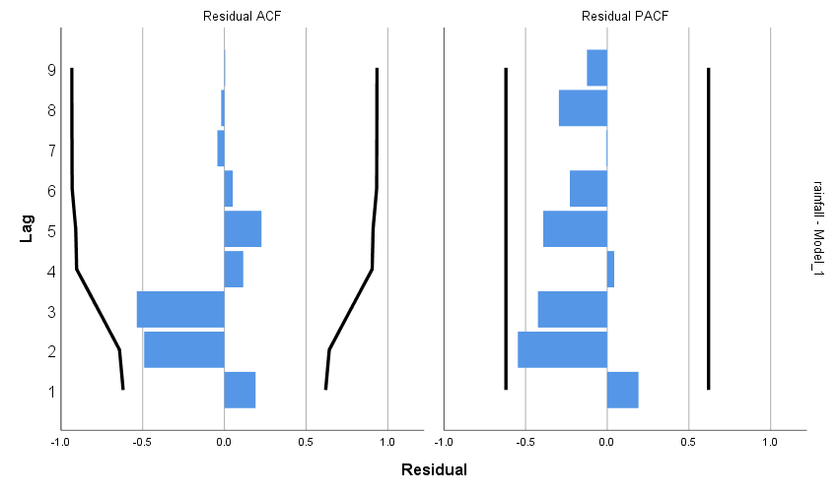

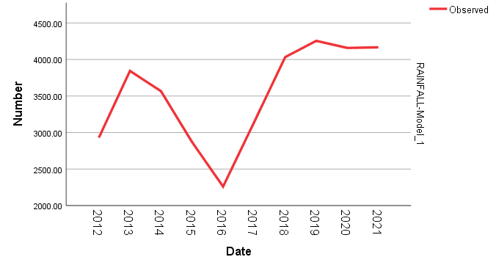

INFERENCE:

1) Annual rainfall analysis shows an increasing trend.

2) 2019 has the highest rainfall during the period 2012-2021.

3) 2016 has the least rainfall during the period 2012-2021.

MALAPPURAM

SEASONAL RAINFALL ANALYSIS

|  |  |
| --- | --- |
| **Seasonal Factors** | |
| Series Name: RAINFALL | |
| Period | Seasonal Factor (%) |
| 1 | .6 |
| 2 | 40.0 |
| 3 | 305.1 |
| 4 | 54.4 |

**Model Summary**

|  |  |  |  |  |  |  |
| --- | --- | --- | --- | --- | --- | --- |
| **Model Fit** | | | | | | |
| Fit Statistic | Mean | SE | Minimum | Maximum | Percentile | |
| 5 | 10 |
| Stationary R-squared | .660 | . | .660 | .660 | .660 | .660 |
| R-squared | .878 | . | .878 | .878 | .878 | .878 |
| RMSE | 294.144 | . | 294.144 | 294.144 | 294.144 | 294.144 |
| MAPE | 1032.780 | . | 1032.780 | 1032.780 | 1032.780 | 1032.780 |
| MaxAPE | 23802.183 | . | 23802.183 | 23802.183 | 23802.183 | 23802.183 |
| MAE | 193.079 | . | 193.079 | 193.079 | 193.079 | 193.079 |
| MaxAE | 785.403 | . | 785.403 | 785.403 | 785.403 | 785.403 |
| Normalized BIC | 11.553 | . | 11.553 | 11.553 | 11.553 | 11.553 |

|  |  |  |  |  |  |
| --- | --- | --- | --- | --- | --- |
| **Model Fit** | | | | | |
| Fit Statistic | Percentile | | | | |
| 25 | 50 | 75 | 90 | 95 |
| Stationary R-squared | .660 | .660 | .660 | .660 | .660 |
| R-squared | .878 | .878 | .878 | .878 | .878 |
| RMSE | 294.144 | 294.144 | 294.144 | 294.144 | 294.144 |
| MAPE | 1032.780 | 1032.780 | 1032.780 | 1032.780 | 1032.780 |
| MaxAPE | 23802.183 | 23802.183 | 23802.183 | 23802.183 | 23802.183 |
| MAE | 193.079 | 193.079 | 193.079 | 193.079 | 193.079 |
| MaxAE | 785.403 | 785.403 | 785.403 | 785.403 | 785.403 |
| Normalized BIC | 11.553 | 11.553 | 11.553 | 11.553 | 11.553 |

|  |  |  |  |  |  |
| --- | --- | --- | --- | --- | --- |
| **Model Statistics** | | | | | |
| Model | Number of Predictors | Model Fit statistics | Ljung-Box Q(18) | | |
| Stationary R-squared | Statistics | DF | Sig. |
| RAINFALL-Model_1 | 0 | .660 | 30.721 | 16 | .015 |

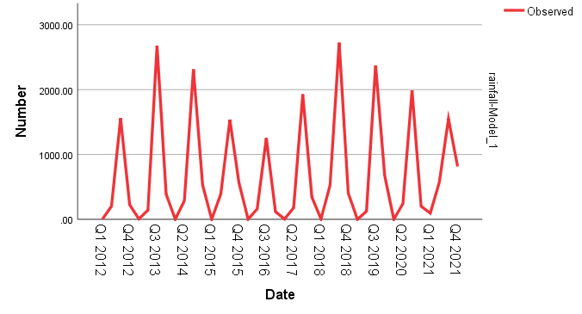

ANNUAL RAINFALL ANALYSIS

**Model Summary**

|  |  |  |  |  |  |  |
| --- | --- | --- | --- | --- | --- | --- |
| **Model Fit** | | | | | | |
| Fit Statistic | Mean | SE | Minimum | Maximum | Percentile | |
| 5 | 10 |
| Stationary R-squared | 7.772E-16 | . | 7.772E-16 | 7.772E-16 | 7.772E-16 | 7.772E-16 |
| R-squared | 7.772E-16 | . | 7.772E-16 | 7.772E-16 | 7.772E-16 | 7.772E-16 |
| RMSE | 645.878 | . | 645.878 | 645.878 | 645.878 | 645.878 |
| MAPE | 22.452 | . | 22.452 | 22.452 | 22.452 | 22.452 |
| MaxAPE | 76.821 | . | 76.821 | 76.821 | 76.821 | 76.821 |
| MAE | 532.150 | . | 532.150 | 532.150 | 532.150 | 532.150 |
| MaxAE | 1177.670 | . | 1177.670 | 1177.670 | 1177.670 | 1177.670 |
| Normalized BIC | 13.171 | . | 13.171 | 13.171 | 13.171 | 13.171 |

|  |  |  |  |  |  |
| --- | --- | --- | --- | --- | --- |
| **Model Fit** | | | | | |
| Fit Statistic | Percentile | | | | |
| 25 | 50 | 75 | 90 | 95 |
| Stationary R-squared | 7.772E-16 | 7.772E-16 | 7.772E-16 | 7.772E-16 | 7.772E-16 |
| R-squared | 7.772E-16 | 7.772E-16 | 7.772E-16 | 7.772E-16 | 7.772E-16 |
| RMSE | 645.878 | 645.878 | 645.878 | 645.878 | 645.878 |
| MAPE | 22.452 | 22.452 | 22.452 | 22.452 | 22.452 |
| MaxAPE | 76.821 | 76.821 | 76.821 | 76.821 | 76.821 |
| MAE | 532.150 | 532.150 | 532.150 | 532.150 | 532.150 |
| MaxAE | 1177.670 | 1177.670 | 1177.670 | 1177.670 | 1177.670 |
| Normalized BIC | 13.171 | 13.171 | 13.171 | 13.171 | 13.171 |

|  |  |  |  |  |  |
| --- | --- | --- | --- | --- | --- |
| **Model Statistics** | | | | | |
| Model | Number of Predictors | Model Fit statistics | | Ljung-Box Q(18) | |
| Stationary R-squared | R-squared | Statistics | DF |
| RAINFALL-Model_1 | 0 | 7.772E-16 | 7.772E-16 | . | 0 |

|  |  |  |  |  |  |
| --- | --- | --- | --- | --- | --- |
| **ARIMA Model Parameters** | | | | | |
|  | | | | Estimate | SE |
| RAINFALL-Model_1 | RAINFALL | No Transformation | Constant | 2710.670 | 204.245 |

|  |  |  |  |  |  |
| --- | --- | --- | --- | --- | --- |
| **ARIMA Model Parameters** | | | | | |
|  | | | | t | Sig. |
| RAINFALL-Model_1 | RAINFALL | No Transformation | Constant | 13.272 | .000 |

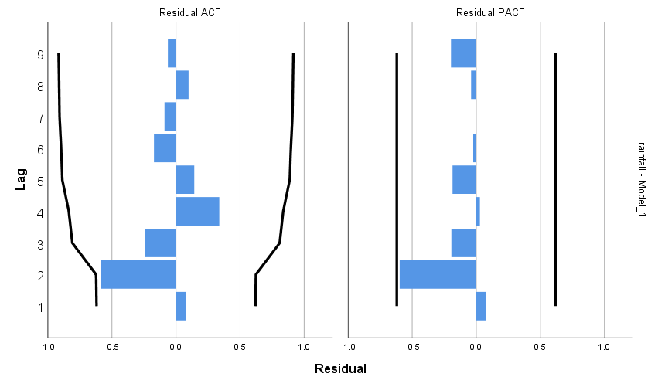

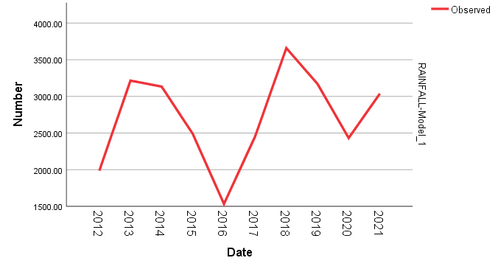

INFERENCE:

1) Annual rainfall analysis shows an increasing trend.

2) 2018 has the highest rainfall during the period 2012-2021.

3) 2016 has the least rainfall during the period 2012-2021.

PALAKKAD

ANNUAL RAINFALL ANALYSIS

|  |  |
| --- | --- |
| **Seasonal Factors** | |
| Series Name: RAINFALL | |
| Period | Seasonal Factor (%) |
| 1 | 1.8 |
| 2 | 49.6 |
| 3 | 297.4 |
| 4 | 51.2 |

**Model Summary**

|  |  |  |  |  |  |  |
| --- | --- | --- | --- | --- | --- | --- |
| **Model Fit** | | | | | | |
| Fit Statistic | Mean | SE | Minimum | Maximum | Percentile | |
| 5 | 10 |
| Stationary R-squared | .653 | . | .653 | .653 | .653 | .653 |
| R-squared | .848 | . | .848 | .848 | .848 | .848 |
| RMSE | 267.572 | . | 267.572 | 267.572 | 267.572 | 267.572 |
| MAPE | 271.983 | . | 271.983 | 271.983 | 271.983 | 271.983 |
| MaxAPE | 7134.947 | . | 7134.947 | 7134.947 | 7134.947 | 7134.947 |
| MAE | 167.978 | . | 167.978 | 167.978 | 167.978 | 167.978 |
| MaxAE | 821.138 | . | 821.138 | 821.138 | 821.138 | 821.138 |
| Normalized BIC | 11.363 | . | 11.363 | 11.363 | 11.363 | 11.363 |

|  |  |  |  |  |  |
| --- | --- | --- | --- | --- | --- |
| **Model Fit** | | | | | |
| Fit Statistic | Percentile | | | | |
| 25 | 50 | 75 | 90 | 95 |
| Stationary R-squared | .653 | .653 | .653 | .653 | .653 |
| R-squared | .848 | .848 | .848 | .848 | .848 |
| RMSE | 267.572 | 267.572 | 267.572 | 267.572 | 267.572 |
| MAPE | 271.983 | 271.983 | 271.983 | 271.983 | 271.983 |
| MaxAPE | 7134.947 | 7134.947 | 7134.947 | 7134.947 | 7134.947 |
| MAE | 167.978 | 167.978 | 167.978 | 167.978 | 167.978 |
| MaxAE | 821.138 | 821.138 | 821.138 | 821.138 | 821.138 |
| Normalized BIC | 11.363 | 11.363 | 11.363 | 11.363 | 11.363 |

|  |  |  |  |  |  |
| --- | --- | --- | --- | --- | --- |
| **Model Statistics** | | | | | |
| Model | Number of Predictors | Model Fit statistics | Ljung-Box Q(18) | | |
| Stationary R-squared | Statistics | DF | Sig. |
| RAINFALL-Model_1 | 0 | .653 | 26.600 | 16 | .046 |

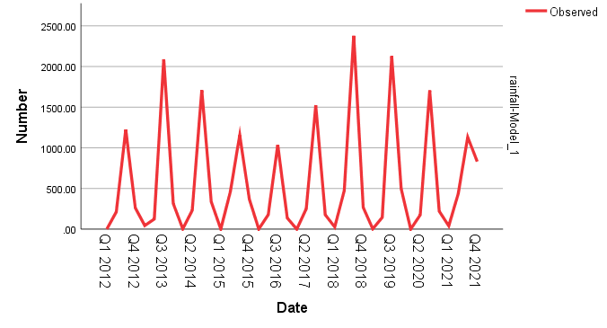

ANNUAL RAINFALL ANALYSIS

**Model Summary**

|  |  |  |  |  |  |
| --- | --- | --- | --- | --- | --- |
| **Model Fit** | | | | | |
| Fit Statistic | Mean | SE | Minimum | Maximum | Percentile |
| 5 |
| Stationary R-squared | -3.553E-15 | . | -3.553E-15 | -3.553E-15 | -3.553E-15 |
| R-squared | -3.553E-15 | . | -3.553E-15 | -3.553E-15 | -3.553E-15 |
| RMSE | 484.575 | . | 484.575 | 484.575 | 484.575 |
| MAPE | 17.118 | . | 17.118 | 17.118 | 17.118 |
| MaxAPE | 41.261 | . | 41.261 | 41.261 | 41.261 |
| MAE | 395.750 | . | 395.750 | 395.750 | 395.750 |
| MaxAE | 745.830 | . | 745.830 | 745.830 | 745.830 |
| Normalized BIC | 12.597 | . | 12.597 | 12.597 | 12.597 |

|  |  |  |  |  |  |
| --- | --- | --- | --- | --- | --- |
| **Model Fit** | | | | | |
| Fit Statistic | Percentile | | | | |
| 10 | 25 | 50 | 75 | 90 |
| Stationary R-squared | -3.553E-15 | -3.553E-15 | -3.553E-15 | -3.553E-15 | -3.553E-15 |
| R-squared | -3.553E-15 | -3.553E-15 | -3.553E-15 | -3.553E-15 | -3.553E-15 |
| RMSE | 484.575 | 484.575 | 484.575 | 484.575 | 484.575 |
| MAPE | 17.118 | 17.118 | 17.118 | 17.118 | 17.118 |
| MaxAPE | 41.261 | 41.261 | 41.261 | 41.261 | 41.261 |
| MAE | 395.750 | 395.750 | 395.750 | 395.750 | 395.750 |
| MaxAE | 745.830 | 745.830 | 745.830 | 745.830 | 745.830 |
| Normalized BIC | 12.597 | 12.597 | 12.597 | 12.597 | 12.597 |

|  |  |  |  |  |  |
| --- | --- | --- | --- | --- | --- |
| **Model Statistics** | | | | | |
| Model | Number of Predictors | Model Fit statistics | | Ljung-Box Q(18) | |
| Stationary R-squared | R-squared | Statistics | DF |
| RAINFALL-Model_1 | 0 | -3.553E-15 | -3.553E-15 | . | 0 |

|  |  |  |  |  |  |
| --- | --- | --- | --- | --- | --- |
| **ARIMA Model Parameters** | | | | | |
|  | | | | Estimate | SE |
| RAINFALL-Model_1 | RAINFALL | No Transformation | Constant | 2398.470 | 153.236 |

|  |  |  |  |  |  |
| --- | --- | --- | --- | --- | --- |
| **ARIMA Model Parameters** | | | | | |
|  | | | | t | Sig. |
| RAINFALL-Model_1 | RAINFALL | No Transformation | Constant | 15.652 | .000 |

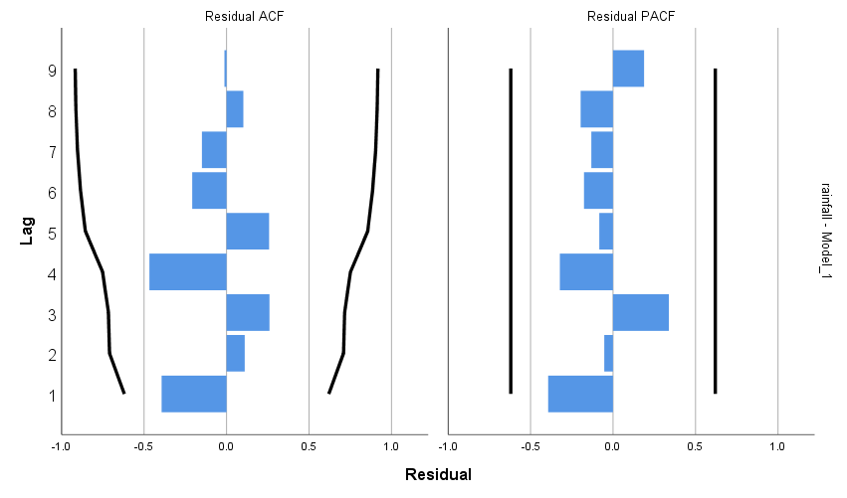

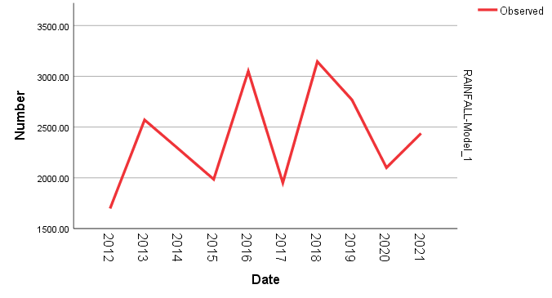

INFERENCE:

1) Annual rainfall analysis shows an increasing trend.

2) 2018 has the highest rainfall during the period 2012-2021.

3) 2012 has the least rainfall during the period 2012-2021.

**CHAPTER 4**

**CONCLUSION**

* Since R2 value of Seasonal trend analysis of Kasaragod is 0.942.So the model is suitable for time series analysis.
* Since R2 value of Seasonal trend analysis of Kannur is 0.929.So the model is suitable for time series analysis.
* Since R2 value of Seasonal trend analysis of Wayanad is 0.855.So the model is suitable for time series analysis.
* Since R2 value of Seasonal trend analysis of Kozhikode is 0.927.So the model is suitable for time series analysis.
* Since R2 value of Seasonal trend analysis of Malappuram is 0.878.So the model is suitable for time series analysis.
* Since R2 value of Seasonal trend analysis of Palakkad is 0.848.So the model is suitable for time series analysis.
* Since R2 value Of Annual rainfall analysis of Kasaragod is 0.265.So the model is not suitable for time series analysis.
* Since R2 value Of Annual rainfall analysis of Kannur is 5.995E-15.So the model is not suitable for time series analysis.
* Since R2 value Of Annual rainfall analysis of Wayanad is 1.665E-15.So the model is not suitable for time series analysis.
* Since R2 value Of Annual rainfall analysis of Kozhikode is 0.198.So the model is not suitable for time series analysis.
* Since R2 value Of Annual rainfall analysis of Malappuram is 7.772E-16.So the model is not suitable for time series analysis.
* Since R2 value Of Annual rainfall analysis of Palakkad is -3.553E-15.So the model is not suitable for time series analysis.
* In each year, the seasonal factor of the seasonal monsoon is greater than others. So the chance of getting more rain and other consequences due to rain is more in this season than other.
* Clearly in each year, the seasonal factor of winter season is generally less than other season .it indicates the rainfall rate is much less than this time and consequences caused due to rain is not seen in any year. By looking the trend of the rainfall in winter season for years, we can see the trend generally less than others.
* 2016 shows the lowest rainfall during the period 2012-2021.

**CHAPTER 5**

**BIBILIOGRAPHY**

1. SC Gupta and VK Kapoor (1989), Fundamentals of Mathematical Statistics, *Sultan Chand & Sons*, Eleventh Edition.
2. SC Gupta and VK Kapoor (2007), Fundamentals of Applied Statistics, 2007, Published by *Sultan Chand & Sons*, Fourth edition.
3. Indian Meteorological Department Website(<https://mausam.imd.gov.in>)
4. Kerala State Tourism Department website(<https://www.keralatourism.org>)

**CHAPTER 6**

**APPENDIX**

ANNUAL & SEASONAL RAINFALL DATA:

2012

|  |  |  |  |  |  |
| --- | --- | --- | --- | --- | --- |
| **DISTRICTS** | **Winter** | **Pre-Monsoon** | **Monsoon** | **Post-Monsoon** | **Annual** |
| Kasargod | 0 | 134 | 2739.3 | 172.5 | 3045.8 |
| Kannur | 5.5 | 96.2 | 2317.9 | 247.3 | 2666.9 |
| Wayanad | 8.6 | 221.9 | 1354.8 | 254.6 | 1839.9 |
| Kozhikode | 9.4 | 155.6 | 2390.7 | 374.1 | 2929.8 |
| Malappuram | 2.1 | 203.2 | 1558.92 | 221.8 | 1986.02 |
| Palakkad | 0 | 212.2 | 1223.1 | 262.6 | 1697.9 |

2013

|  |  |  |  |  |  |
| --- | --- | --- | --- | --- | --- |
| **DISTRICTS** | **Winter** | **Pre-Monsoon** | **Monsoon** | **Post-Monsoon** | **Annual** |
| Kasargod | 83.2 | 180.5 | 3086.3 | 220.2 | 3570.2 |
| Kannur | 35.5 | 164.6 | 3441.3 | 381 | 4022.4 |
| wayanad | 11.5 | 238.5 | 2689.6 | 230.7 | 3170.3 |
| Kozhikode | 43.1 | 254.5 | 3166.6 | 379.4 | 3843.6 |
| Malappuram | 7.7 | 141.5 | 2677.7 | 388 | 3214.9 |
| Palakkad | 43.5 | 124.1 | 2089 | 314.2 | 2570.8 |

2014

|  |  |  |  |  |  |
| --- | --- | --- | --- | --- | --- |
| **DISTRICTS** | **Winter** | **Pre-Monsoon** | **Monsoon** | **Post-Monsoon** | **Annual** |
| Kasargod | 0 | 258.8 | 2720.3 | 363.5 | 3342.6 |
| Kannur | 10.7 | 276.6 | 2862.4 | 383.8 | 3533.5 |
| Wayanad | 4.2 | 354.1 | 2559.6 | 341.7 | 3259.6 |
| Kozhikode | 0 | 345.9 | 2773.7 | 446.5 | 3566.1 |
| Malappuram | 1.6 | 286.2 | 2312.2 | 533.1 | 3133.1 |
| Palakkad | 3.1 | 232.4 | 1708.2 | 334.8 | 2278.5 |

2015

|  |  |  |  |  |  |
| --- | --- | --- | --- | --- | --- |
| **DISTRICTS** | **Winter** | **Pre-Monsoon** | **Monsoon** | **Post-Monsoon** | **Annual** |
| Kasargod | 0.9 | 305.8 | 2032 | 407.2 | 2745.8 |
| Kannur | 5 | 278.7 | 2169.6 | 527.3 | 2980.6 |
| Wayanad | 0.1 | 388 | 1592.6 | 301.9 | 2282.6 |
| Kozhikode | 0 | 315.3 | 1995.4 | 559.4 | 2870.1 |
| Malappuram | 0 | 391.4 | 1536 | 560.1 | 2487.5 |
| Palakkad | 2 | 456.9 | 1155.5 | 370.8 | 1985.2 |

2016

|  |  |  |  |  |  |
| --- | --- | --- | --- | --- | --- |
| **DISTRICTS** | **Winter** | **Pre-Monsoon** | **Monsson** | **Post-Monsoon** | **Annual** |
| Kasargod | 3.4 | 138.4 | 2252.9 | 71.1 | 2465.8 |
| Kannur | 0 | 140.2 | 1991 | 84.4 | 2215.6 |
| Wayanad | 3.3 | 145.8 | 1073.8 | 104.9 | 1327.8 |
| Kozhikode | 0 | 298.2 | 1887.4 | 74.5 | 2260.1 |
| Malappuram | 1.8 | 161.7 | 1251.2 | 118.3 | 1533 |
| Palakkad | 0.2 | 177.5 | 1034.8 | 137.6 | 1350.1 |

2017

|  |  |  |  |  |  |
| --- | --- | --- | --- | --- | --- |
| **DISTRICTS** | **Winter** | **Pre-Monsoon** | **Monsoon** | **Post-Monsoon** | **Annual** |
| Kasargod | 18.1 | 87.3 | 2645.6 | 180.1 | 2931.1 |
| Kannur | 11.5 | 235.5 | 2301.3 | 246.1 | 2794.3 |
| Waynad | 14.5 | 293.4 | 1652.1 | 165 | 2125.1 |
| Kozhikode | 7.8 | 341.1 | 2521.6 | 271.5 | 3142.1 |
| Malappuram | 4 | 178.8 | 1928.2 | 343.7 | 2454.8 |
| Palakkad | 0 | 250.9 | 1524 | 176.8 | 1951.7 |

2018

|  |  |  |  |  |  |
| --- | --- | --- | --- | --- | --- |
| **DISTRICTS** | **Winter** | **Pre-Monsoon** | **Monsoon** | **Post-Monsoon** | **Annual** |
| Kasargod | 4.8 | 438.9 | 2426.2 | 208.5 | 3078.3 |
| Kannur | 2 | 444.9 | 2642.1 | 304.6 | 3393.5 |
| Wayanad | 11.2 | 451.6 | 3068.2 | 301 | 3831.9 |
| Kozhikode | 8.5 | 678.8 | 2984.4 | 360.2 | 4032 |
| Malappuram | 5.9 | 528.1 | 2723.7 | 401 | 3658.6 |
| Palakkad | 25.7 | 474 | 2377.9 | 266.7 | 3144.3 |

2019

|  |  |  |  |  |  |
| --- | --- | --- | --- | --- | --- |
| **DISTRICTS** | **Winter** | **Pre-Monsoon** | **Monsoon** | **Post-Monsoon** | **Annual** |
| Kasargod | 0 | 64 | 3420.2 | 630.7 | 4114.9 |
| Kannur | 0 | 72.9 | 3134.1 | 610.1 | 3817.1 |
| Wayanad | 14.5 | 269.3 | 2377.2 | 463.3 | 3124.3 |
| Kozhikode | 0 | 88.2 | 3469.7 | 697.2 | 4255 |
| Malappuram | 0.4 | 126.1 | 2371.1 | 672.9 | 3170.6 |
| Palakkad | 3.8 | 144.3 | 2127.9 | 492.1 | 2768.2 |

2020

|  |  |  |  |  |  |
| --- | --- | --- | --- | --- | --- |
| **DISTRICTS** | **Winter** | **Pre-Monsoon** | **Monsoon** | **Post-Monsoon** | **Annual** |
| Kasargod | 2.1 | 126.7 | 3605.6 | 394 | 4128.4 |
| Kannur | 1 | 214.8 | 3365.9 | 416.1 | 2803.5 |
| Wayanad | 2.3 | 286.9 | 2082.3 | 239.9 | 2611.4 |
| Kozhikode | 0 | 339.6 | 3440.3 | 378.6 | 4158.6 |
| Malappuram | 0.3 | 242.7 | 1987.2 | 200.9 | 2431.1 |
| Palakkad | 0 | 174.7 | 1705.6 | 220 | 2100.3 |

2021

|  |  |  |  |  |  |
| --- | --- | --- | --- | --- | --- |
| **DISTRICTS** | **Winter** | **Pre-Monsoon** | **Monsoon** | **Post-Monsoon** | **Annual** |
| Kasargod | 114 | 488.3 | 2398.7 | 825 | 3826 |
| Kannur | 79.8 | 640 | 2070.6 | 858.5 | 3648.9 |
| Wayanad | 85.1 | 467 | 1725.5 | 569.7 | 2847.3 |
| Kozhikode | 170.5 | 674.5 | 2288.4 | 1032.9 | 4166.3 |
| Malappuram | 95.2 | 574.5 | 1550.1 | 817 | 3036.9 |
| Palakkad | 39.7 | 434.7 | 1131.6 | 831.9 | 2437.7 |